
DJPC’s 2010 Salon Discussion Series Presents
2009 DJPC School of the Americas Protesters 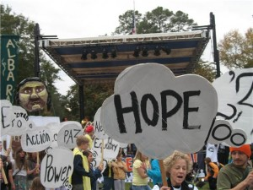
Image by Sarah Sloane
Irene Rodriguez, Kathryn Rodriguez, Jane Covode,
Tommy Timm, and Sarah Sloane
invite you to join them and others who have demonstrated at the Fort Benning SOA(School of the Americas) throughout two decades to commemorate 20 years of action to close the SOA. Learn about current legislation in the U.S. congress and grassroots movements in Latin America to close the U.S. Army school that trains Latin American military.

Thursday March 18th
7:00-9:00 PM

Denver Justice & Peace Committee
Denver Inner City Parish
Community Room
1212 Mariposa Street, Denver 80204

Free parking is available along the street as well as in the lots beside the building. Enter the building through the side entrance off of 12th street.

Website: www.denjustpeace.org
Phone: 303-623-1463

Denver Justice and Peace Committee (DJPC) is a volunteer organization dedicated to promoting human rights, economic justice, and lasting peace in Latin America through education, solidarity projects, and nonviolent activism.

